Weyland Energy – Equity Story
One page for investors and lenders
Noah Fischer · 14 April 2026
Clean power, built to last. Weyland develops, builds and operates wind, solar and storage assets across Northern Europe – 1.1 GW in operation, a 4.2 GW pipeline and 450 people in Hamburg, Edinburgh and Copenhagen.
- Proven operator: 2,860 GWh generated in 2025, Kestrel Ridge availability 97.4 %.
- Profitable growth: revenue EUR 312 m (+13 %), EBITDA EUR 148 m (47 % margin).
- De-risked flagship: Harrow Bay (480 MW) fully financed, in construction, COD June 2028.
- Industrial partnerships: 15-year PPA with Arcturus Steel; green hydrogen pilot.
- ESG leadership: 1.2 Mt CO₂ avoided, 96 % taxonomy-aligned revenue, ISO 9001/14001/45001.
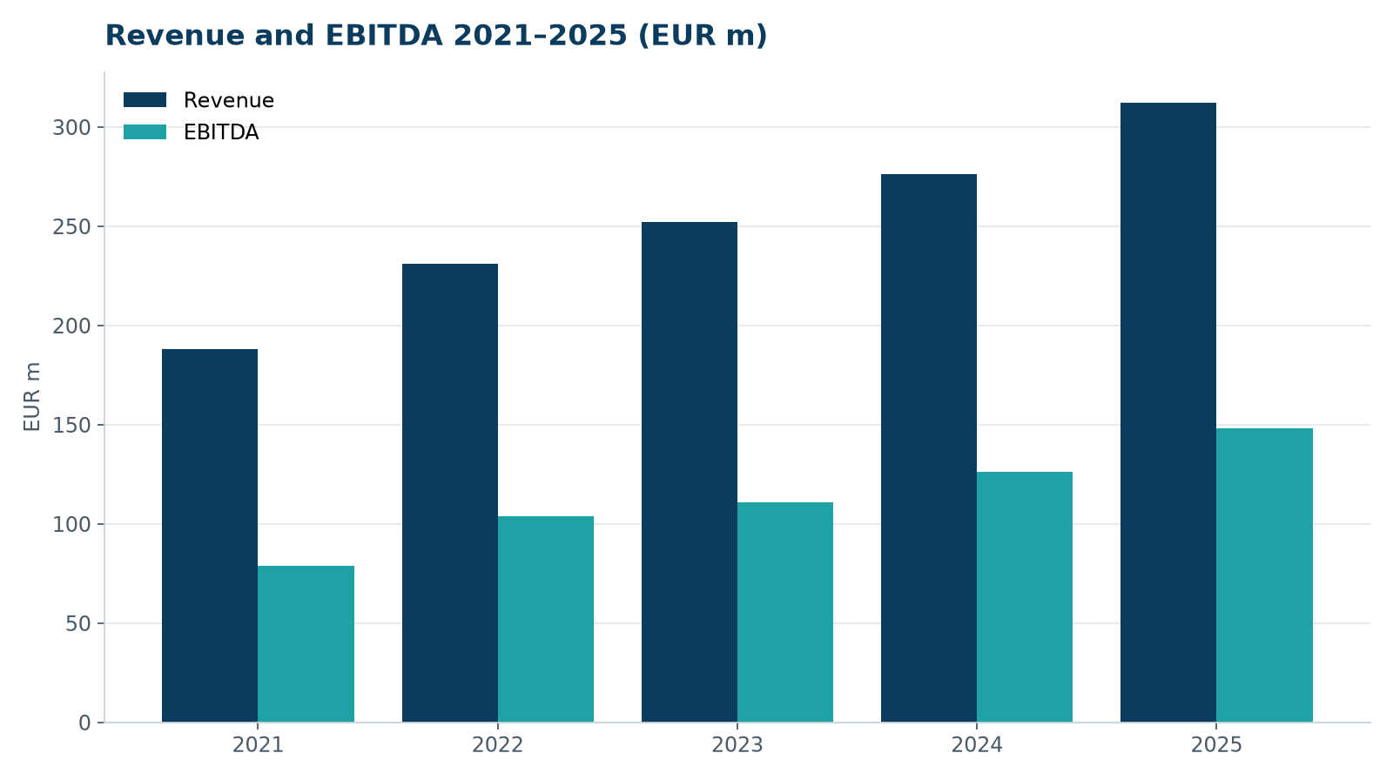
Revenue and EBITDA 2021–2025

